**Using the data below for Pizza USA, answer the following questions.**

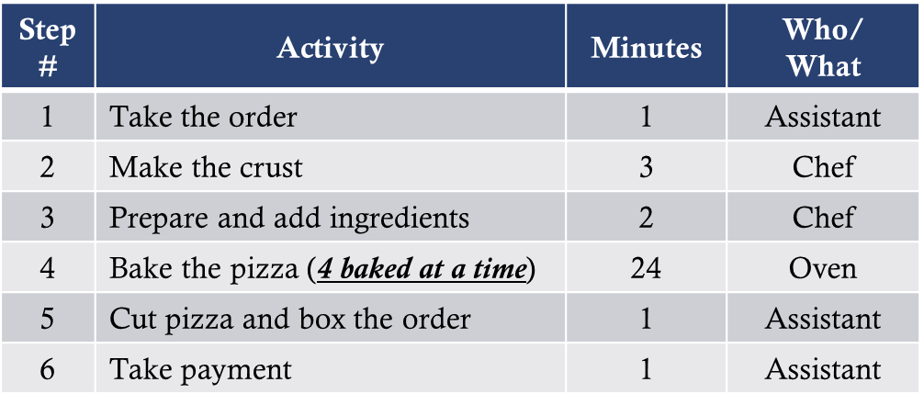

1. **What is THROUGHPUT TIME?**

**1 + 3 + 2 + 24 + 1 + 1 = 32**

1. **Which step is the BOTTLENECK?**

**Step #4 is the bottle neck as it takes the longest with the fewest items going through. It takes 6 minutes to bake each pizza.**

1. **What is the CAPACITY of the process?**

**60 / (24 / 4) = 10 pizzas per hour**